The Estimation of Amazon Delivery Performance Analysis

Medine Yazıcı
Departmant of Statistics
Middle East Technical University

Abstract— This project involves a study using analytical and predictive modelling to examine the factors that influence Amazon’s delivery processes. The dataset used in the project includes detailed information on over 43,000 orders. It covers many variables such as order time, pick-up time, weather and traffic conditions, type of delivery vehicle, delivery area, product category, and characteristics of the agent performing the delivery. Supervised machine learning algorithms including Linear Regression, Artificial Neural Network (MLPRegressor), Support Vector Machines, Random Forest and XGBoost were utilized to estimate delivery times. Prior to model development, data preparation steps such as data analysis, feature engineering, clustering, and handling missing data were completed. The models were evaluated using performance metrics such as Root Mean Square Error (RMSE), Mean Absolute Error (MAE), R-squared (R²), and Mean Absolute Percentage Error (MAPE). R was used in pre-preparation processes and Python was used in modeling stages.

Introduction
With the growth of e-commerce, timely and reliable delivery has become a key factor in determining customer satisfaction. Optimizing delivery times on large platforms like Amazon is crucial for maintaining competitiveness against other major companies. This study aims to analyze the factors that affect delivery time using various machine learning methods and to develop a reliable prediction model.
In this study, different machine learning models such as Multiple Linear Regression, Support Vector Regression (SVM), Artificial Neural Networks (ANN), Random Forest (RF), and XGBoost were comparatively evaluated. To increase the predictive accuracy and to create a solid foundation for model construction, conducted a thorough exploratory data analysis (EDA) on the dataset.
The dataset comprises multiple variables, such as order timing, traffic density, courier characteristics, weather conditions, and geographical location. Our goal is to analyze the factors that influence delivery time and develop models capable of predicting this time. The findings from this research not only contribute to academic knowledge but also offer significant practical benefits, such as improving logistics processes and enhancing customer satisfaction.

LITERATURE REVİEW
As e-commerce continues to expand rapidly, timely and accurate deliveries have become crucial for ensuring customer satisfaction and loyalty. Research shows that delivery delays are a major factor influencing negative customer experiences (Zhang et al., 2020). Predictive models have been increasingly used to improve delivery performance, with machine learning methods such as Random Forest and XGBoost outperforming traditional techniques (Chen & Guestrin, 2016). This study builds on that literature by comparing five regression models using real-world Amazon delivery data. The results confirm that advanced ensemble methods like XGBoost can significantly improve delivery time predictions, supporting better logistics planning and customer service in e-commerce.

METHODOLOGY

Dataset
The dataset utilized in this project is called the “Amazon Delivery Dataset,” which was published on the Kaggle platform and sourced from an open data repository. It contains 43,739 observations related to Amazon’s last-mile delivery processes. It includes variables concerning order details, logistics operations information, environmental conditions, and delivery times. The variables included in the dataset are as follows:
- Agent_Age: The age of the delivery agent performing the delivery.
- Agent_Rating: The rating of the delivery agent given by the customer.
- Store_Latitude & Store_Longitude: The latitude and longitude coordinates of the store which the order was picked up.
- Drop_Latitude & Drop_Longitude: The latitude and longitude coordinates of the point where the order was delivered.
- Order_Date: The date the order was placed.
- Order_Time: The time the order was placed.
- Pickup_Time: The time at which the order was picked up by the delivery agent.
- Weather: The weather conditions observed during the delivery.
- Traffic: The traffic density encountered during the delivery.
- Vehicle: The type of vehicle used for the delivery.
- Area: The type of area where the delivery was made.
- Delivery_Time: The duration (in minutes) from the moment the order was picked up to when it reached the customer.
- Category: Category of the ordered product.
In this project, the ‘Delivery_Time’ variable is determined as the dependent variable. It directly represents the delivery time in minutes and is considered the key performance indicator to measure delivery efficiency.

Descriptive Statistics

This section presents descriptive statistics for the most frequently used continuous variables in the project: Agent_Age, Agent_Rating, and Delivery_Time. These variables represent key aspects of delivery performance and courier characteristics, playing a central role in the subsequent analysis.

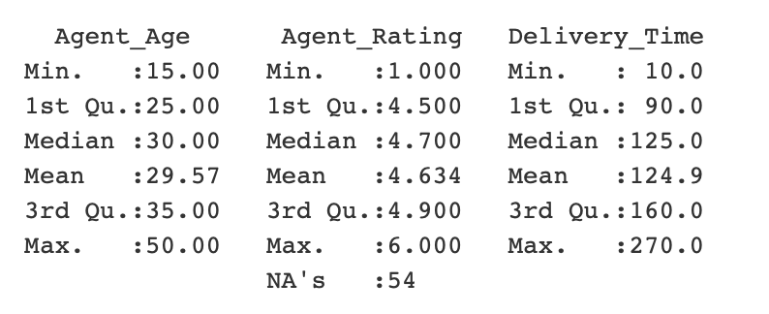
Figure 1 Summary of Continuous Variables
The average age of delivery agents is approximately 29.57, with ages ranging from 15 to 50 years. The Agent_Rating variable ranges from 1.0 to 6.0, with a mean of 4.63 and a median of 4.7, suggesting that most agents receive relatively high performance ratings, though there are 54 missing values.
The Delivery_Time variable, which represents the delivery duration in minutes, ranges from 10 to 270 minutes, with a mean of approximately 125 minutes. The 1st and 3rd quartiles (90 and 160) show that most deliveries are completed within a 70-minute window, but some deliveries take significantly longer, possibly indicating delays due to factors like traffic or weather.
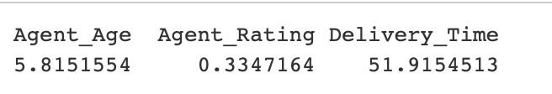
Figure 2 Mean of Continuous Variables
The average delivery agent age is 29.6 years with a standard deviation of 5.82, indicating a fairly narrow spread around the mean. Agent ratings are concentrated around a high average of 4.63 with a low standard deviation of 0.33, suggesting that most agents receive consistently high scores, with 54 missing observations.
The average delivery time is 125 minutes, but the standard deviation is 51.92, indicating substantial variability across deliveries. This spread may be influenced by external factors such as weather conditions, road traffic, or delivery distance.
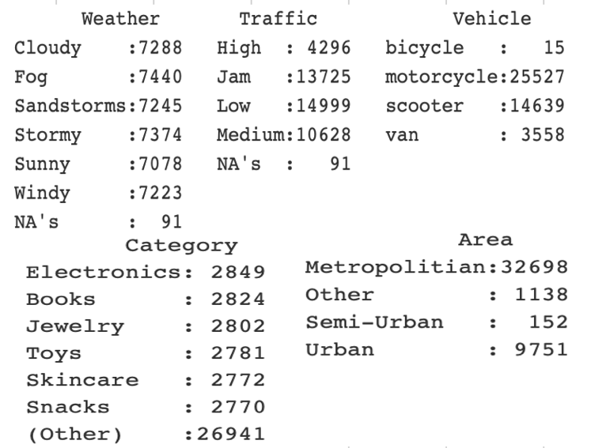
Figure 3 Categoric Variables
The dataset includes several categorical variables. For the weather variable, the most frequent conditions are Cloudy (7288), Fog (7440), and Sandstorms (7245), with similar frequencies across categories. There are 91 missing values. For traffic, the most common condition is Low (14999), followed by Jam (13725) and Medium (10628), also with 91 missing entries. Among vehicle types, Motorcycle is used the most (25527), followed by Scooter (14639) and Van (3558), while Bicycle is rarely used (15). In the area variable, most deliveries occur in Metropolitan areas (32698), followed by Urban areas (9751). Semi-Urban and Other areas have much fewer deliveries. In the category variable, the majority of deliveries are in the Other category (26941). Among specific categories, Electronics (2849), Books (2824), and Jewelry (2802) are the most common.

Exploratory Data Analysis
In this section, exploratory data analysis (EDA) was conducted to better understand the factors influencing delivery time. Several hypotheses were proposed based on common assumptions in delivery logistics. The aim was to visually and statistically examine the relationships between delivery time and other variables such as traffic, distance, weather, agent performance, and vehicle type. Below are the research questions formulated to guide this analysis.

- How does traffic density impact the delivery time?

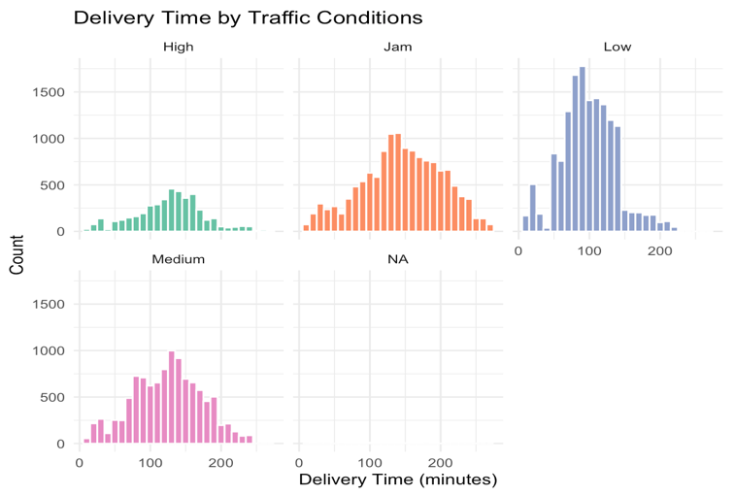
Figure 4 Histogram of Delivery Time by Traffic Conditions
The histogram below illustrates the distribution of delivery times under different traffic conditions. Deliveries made during low traffic show the shortest delivery times overall, with the distribution peaking around 110–120 minutes. In contrast, during jammed traffic, delivery times are more spread out and centered around higher values, suggesting significant delays. Medium and high traffic conditions fall in between, with delivery times increasing as traffic becomes more intense. To test this observation formally, a Kruskal-Wallis rank sum test was conducted.

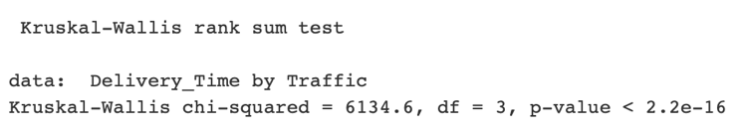

The test returned a p-value far below the 0.05 significance level, leading to the rejection of the null hypothesis. This confirms that delivery time significantly differs across traffic conditions. The result supports the EDA insight that jammed traffic is associated with longer delivery durations

- Does weather condition affect delivery time?

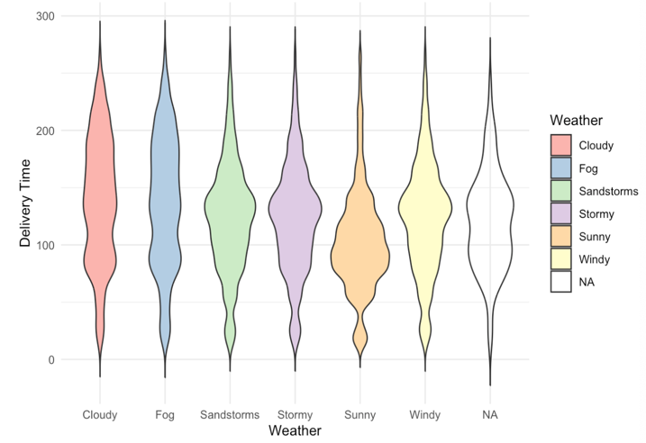
Figure 5 Violin Plot of Delivery Time Distribution by Weather
The violin plot shows that delivery times vary slightly across different weather conditions. Sunny and Windy conditions tend to have slightly shorter delivery times, while Stormy and Foggy days show wider spreads, indicating more delays. Most weather types have a similar overall shape, centered around 100–150 minutes.

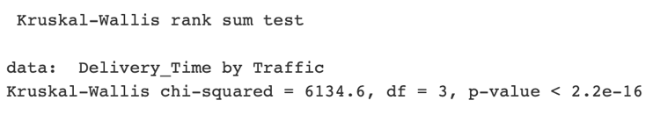

Particularly, deliveries under stormy or foggy weather showed longer and more variable durations. To confirm this pattern statistically, a Kruskal-Wallis rank sum test was performed. Given the extremely small p-value, we reject the null hypothesis. This provides strong statistical evidence that delivery time significantly differs across weather conditions.

- Does delivery time significantly vary across different delivery areas?
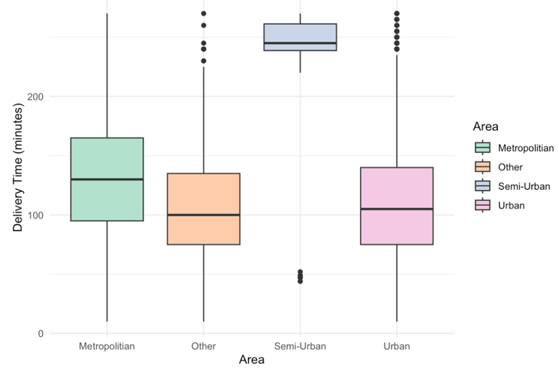
Figure 6 Boxplot of Delivery Time by Area

The boxplot compares delivery durations across different area types. Deliveries in Semi-Urban areas have the highest median time and the least variability, indicating consistently longer deliveries. In contrast, Other and Urban areas show lower median delivery times, with wider spreads and more variability. Metropolitan areas exhibit a moderate median but include many short deliveries, as indicated by the lower whisker. These differences suggest that geographical area plays a significant role in delivery efficiency

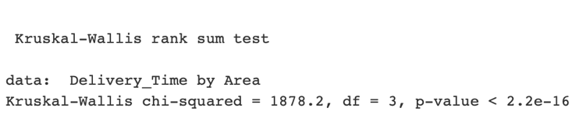

To test whether these observed differences are statistically significant, a Kruskal-Wallis rank sum test was conducted. The p-value is far below 0.05, we reject the null hypothesis. This confirms that delivery time significantly differs across area types. The result supports the earlier EDA findings, where Semi-Urban areas showed longer delivery durations compared to Urban and Metropolitian regions.

- How does the ordering time affect delivery time?

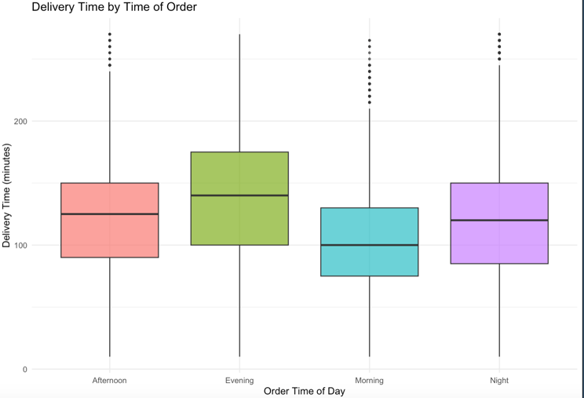
Figure 7 Histogram of Delivery Time by Ordering time

EDA revealed that delivery times might vary depending on the time of day the order was placed. Specifically, orders placed during the evening or night appeared to take longer to be delivered. To formally assess whether this observed difference is statistically significant, a Kruskal-Wallis rank sum test was conducted.

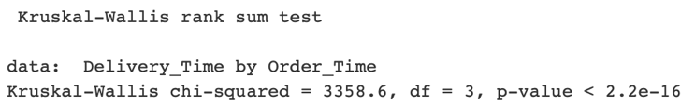

The p-value is far below 0.05, we reject the null hypothesis. This confirms that delivery time significantly varies by the time of day the order is placed. The result supports the EDA insight that deliveries initiated in the evening or at night tend to experience longer durations compared to those placed in the morning or afternoon.

- Is there a significant relationship between agent and age with delivery time?

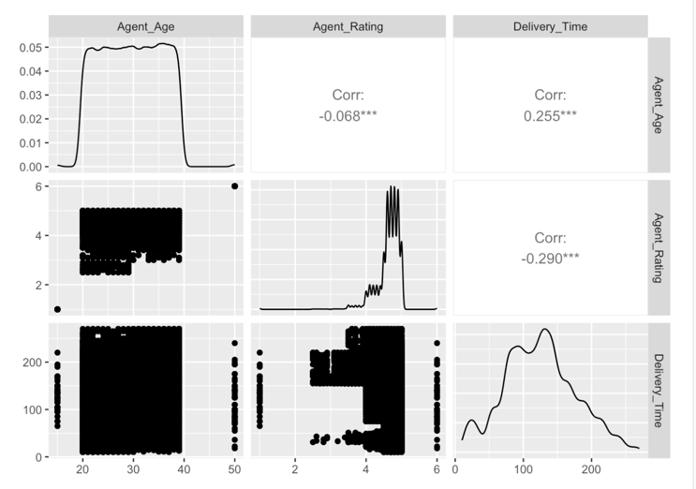
Figure 8 Scatterplot Matrix

A pairwise scatterplot matrix revealed that delivery time is moderately and negatively correlated with agent rating (–0.290), suggesting higher-rated agents tend to deliver faster. A weak positive correlation (0.255) was found between agent age and delivery time, implying older agents may take slightly longer. The relationship between agent age and rating was negligible (–0.068).

To examine whether delivery performance is associated with delivery agent characteristics, two separate correlation analyses were conducted: one between Delivery_Time and Agent_Rating, and another between Delivery_Time and Agent_Age. Since the Delivery_Time variable is not normally distributed (as shown in the Jarque-Bera test), and the data contains ties, the Spearman rank correlation method was used instead of Pearson correlation.

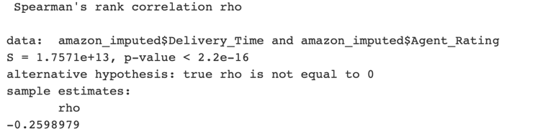
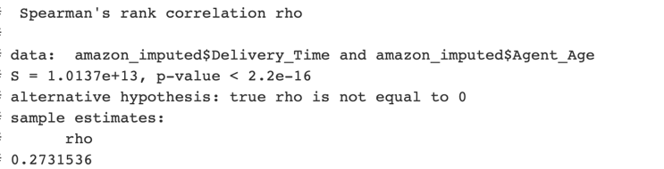

The correlation between Delivery_Time and Agent_Rating was ρ = -0.26 with a p-value < 2.2e-16.
This indicates a statistically significant negative correlation, suggesting that higher-rated agents tend to deliver more quickly. The correlation between Delivery_Time and Agent_Age was ρ = 0.27 with a p-value < 2.2e-16.
This indicates a statistically significant positive correlation, meaning that older agents tend to take slightly longer to complete deliveries.

Missingness
There are missing values in four variables: Agent_Rating 54 missing, and Order_Time, Weather, and Trafficeach with 91 missing.
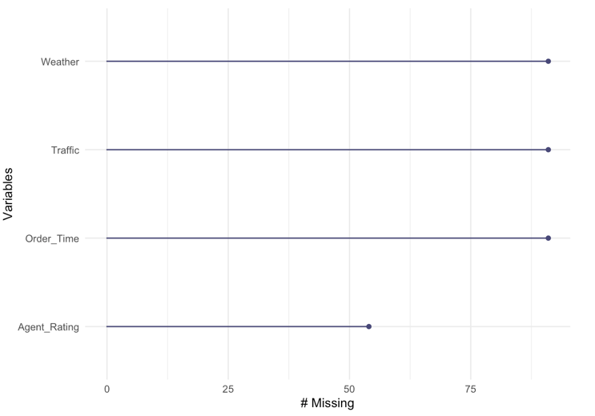
Figure 9 Dot Plot of Missing Values

The variables Order_Time, Weather, and Traffic are missing in the same rows. This pattern suggests that the delivery may not have been completed or recorded properly in those cases. Since their missingness seems related to the delivery situation, these variables are likely Missing At Random (MAR).
In contrast, Agent_Rating is missing in different rows and does not follow the same structure. This variable may represent a predefined score for the delivery agent. If the rating is not collected at the time of delivery but instead reflects an agent’s historical or average score, its absence might be due to system-level data entry issues or missing records for some agents. Therefore, the missing values in Agent_Rating are considered Missing Completely At Random (MCAR).

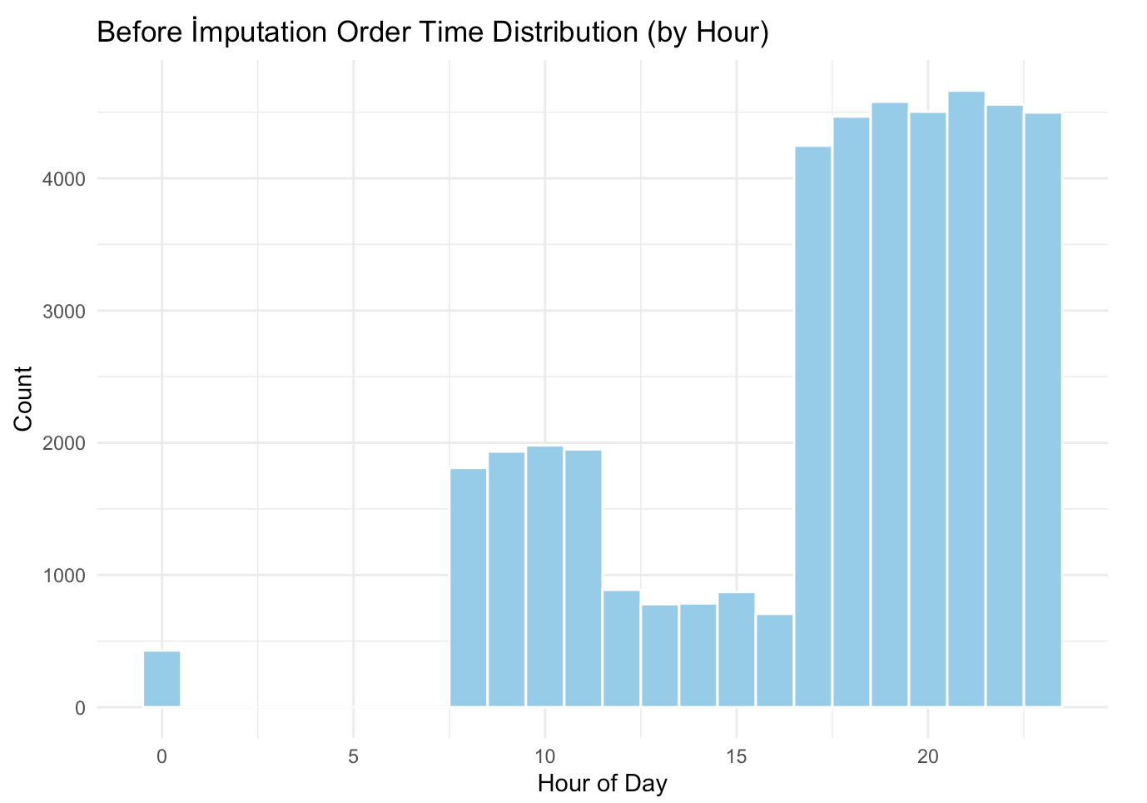
Figure 10

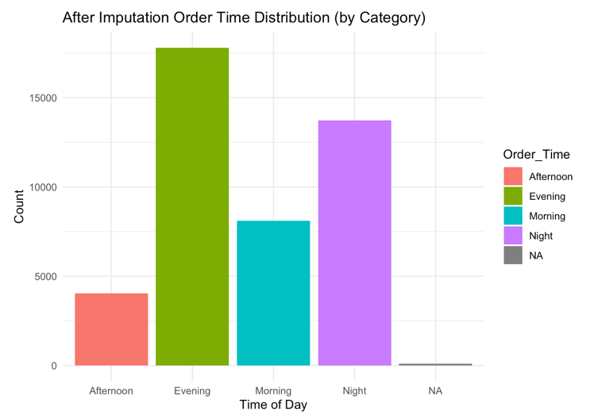
Figure 11

After exploring the missingness mechanism, it was seen that the missing values in Weather, Traffic, and Order_Time(converted to time-of-day categories) are likely Missing At Random (MAR), while the missing values in Agent_Rating are likely Missing Completely At Random (MCAR). Based on this classification, a multiple imputation method was selected.
The MICE (Multiple Imputation by Chained Equations) method was used with predictive mean matching (PMM). This method was chosen because it allows imputing missing values by using patterns from other variables in the dataset. Since the MAR and MCAR assumptions are suitable for MICE, it is a reliable and widely used method in such cases.
To enable MICE-based imputation, Order_Time was transformed from continuous time into a categorical variable with four bins: Morning, Afternoon, Evening, and Night. This transformation aligned with typical order behavior and made the variable suitable for categorical imputation. This decision was made because Order_Time contains missing values and may be useful in the later stages of the project. By converting it into a factor, it was possible to impute its missing values meaningfully within the MICE framework. Along with Order_Time, the variables Agent_Rating, Weather, and Traffic were also included in the imputation model.

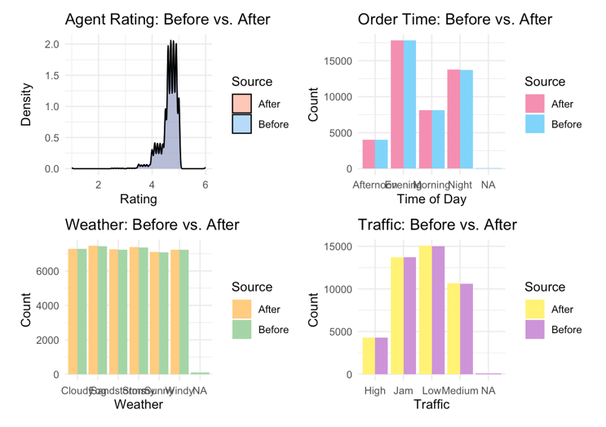
Figure 12

To evaluate the performance and consistency of the imputation process, the variables that initially contained missing values Agent_Rating, Order_Time, Weather, and Traffic were visualized before and after applying MICE.
The density plot for Agent_Rating shows that the distribution remained consistent, indicating that the imputed values did not distort the original structure. The bar plots for Order_Time, Weather, and Traffic further demonstrate that the categorical distributions were preserved. The disappearance of the NA bars in the “After” plots confirms that all missing values were successfully imputed.
These visual validations support the appropriateness of using MICE with Predictive Mean Matching and confirm that the integrity of the dataset was maintained.

Modelling

The cleaned dataset was imported and preprocessed by applying one-hot encoding to categorical variables to ensure compatibility with machine learning algorithms. The response variable, Delivery_Time, was separated from the predictors. The dataset was then split into training (70%) and test (30%) sets using a fixed random seed to ensure reproducibility. Additionally, a 5-fold cross-validation scheme was prepared to evaluate model performance consistently across all modeling techniques.

- Multiple Linear Regression Model

A multiple linear regression model was applied as a baseline approach to predict delivery time using all available features. The model achieved a satisfactory performance on the test set, with an RMSE of 17.43, MAE of 13.86, R² of 0.8891, and a MAPE of 12.64%. These results indicate that the model explains approximately 89% of the variance in delivery time, demonstrating a reasonably good fit given the complexity of the dataset.

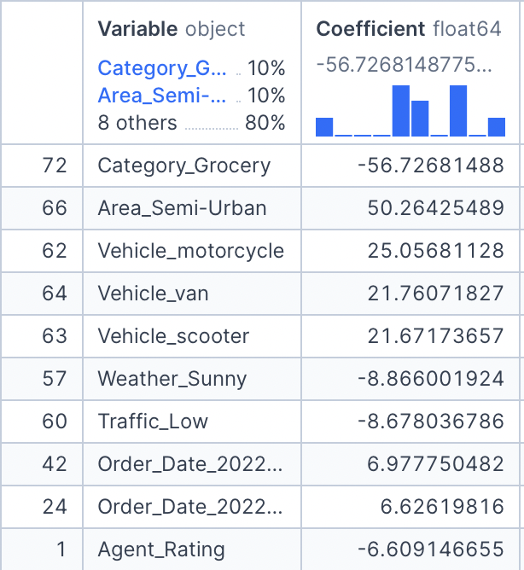

The coefficient analysis revealed that the most influential variables were Category_Grocery (−56.73), Area_Semi-Urban (+50.26), and various vehicle types such as Vehicle_motorcycle and Vehicle_van. A negative coefficient for Category_Grocery implies that grocery deliveries tend to be completed significantly faster, potentially due to operational prioritization. On the other hand, the high positive coefficient for Area_Semi-Urban suggests that deliveries in semi-urban areas take longer, possibly due to logistical or infrastructural constraints.

- Artificial Neural Networks (ANN)

The Artificial Neural Network (ANN) model used in this analysis had two hidden layers and was trained using the ReLU activation function and Adam optimizer. On the test set, it achieved an RMSE of 17.13, MAE of 13.72, R² of 0.893, and a MAPE of 12.84%, showing a slight improvement over the linear regression model.

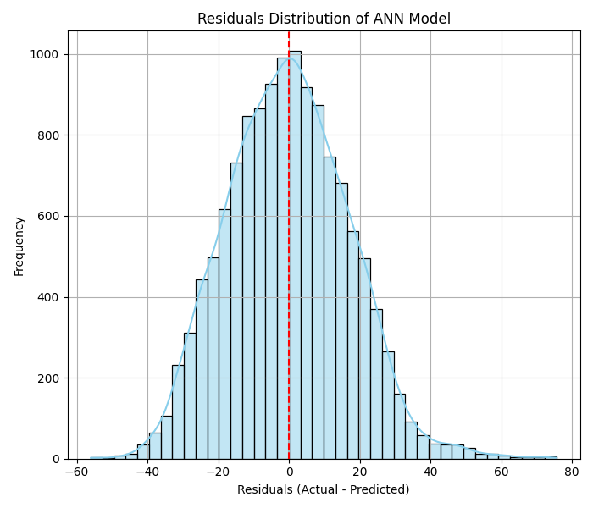
Figure 13

The residual distribution (actual − predicted values) shows a symmetric, bell-shaped curve centered around zero. This suggests that the model’s prediction errors are balanced, meaning it does not consistently overestimate or underestimate delivery times.
The shape of the residuals also looks similar to a normal distribution, which indicates that the model fits the data well. Compared to the linear regression model, the ANN residuals are more tightly grouped around zero, which supports that the ANN captures complex, non-linear relationships better and gives more accurate results.

- SVM (Support Vector Machine)

The Support Vector Machine (SVM) regression model achieved a test RMSE of 17.84, MAE of 13.68, R² of 0.884, and a MAPE of 13.12%. While its performance was slightly below the ANN and Random Forest models, it still demonstrated a strong predictive ability.

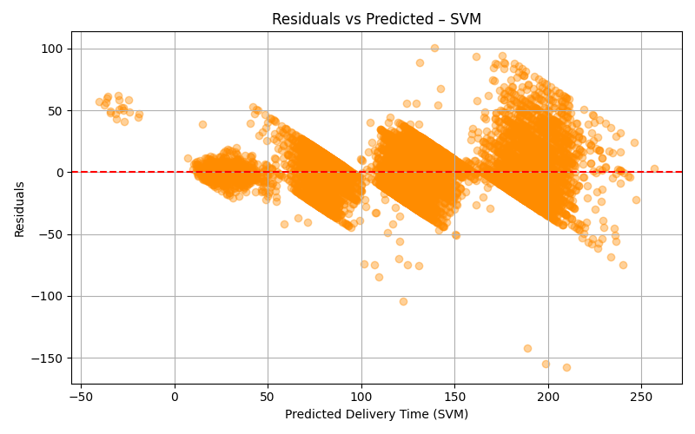
Figure 14

The residuals vs. predicted plot reveals distinct band patterns, which is a common behavior in SVM models due to the way they fit the margin and support vectors. These bands may indicate that the model is less flexible in capturing certain non-linear relationships, especially for extreme values. This pattern also implies that while the overall fit is reasonable, SVM may not generalize as well for all ranges of delivery time.

- Random Forest (RF)

The Random Forest (RF) regression model achieved the best performance among all models, with a test RMSE of 15.02, MAE of 11.76, R² of 0.918, and MAPE of 10.91%. These results show that the model is highly accurate and captures the majority of the variance in delivery time.

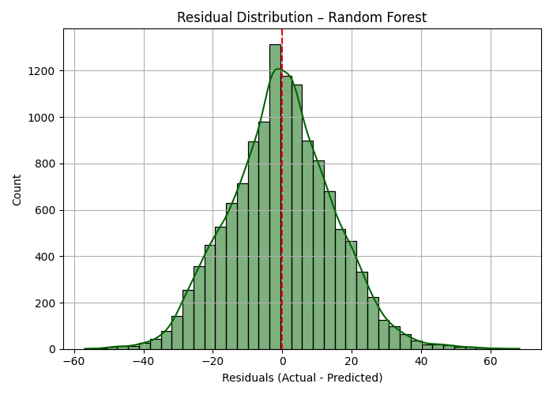
Figure 15

The histogram of residuals is centered around zero with a bell-shaped curve, suggesting that prediction errors are symmetrically distributed and the model is not biased in either direction. Compared to previous models, the residuals are more tightly clustered, indicating lower prediction errors.

- XGBoost Model
The XGBoost regression model achieved the best overall performance across all models evaluated in this study. With a test RMSE of 14.80, MAE of 11.76, R² of 0.919, and MAPE of 10.91%, the model demonstrated strong predictive accuracy and excellent generalization.
These results indicate that XGBoost effectively captured both linear and non-linear relationships in the data, outperforming traditional models such as Linear Regression and even advanced models like ANN and SVM. The high R² value implies that approximately 91.9% of the variation in delivery time was explained by the model.

Performance Comparison on Test Data

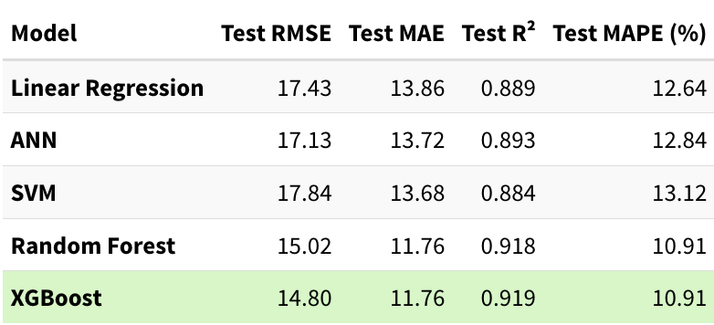
Table 2

The performance of the regression models was compared using four key metrics: Root Mean Squared Error (RMSE), Mean Absolute Error (MAE), Mean Absolute Percentage Error (MAPE), and R-squared (R²). As seen in Table 2 and the heatmap in Figure 16, the XGBoost model achieved the best overall performance, with the lowest RMSE (14.80) and MAE (11.76) values, and the highest R² value (0.919), indicating excellent predictive accuracy and goodness of fit. Its MAPE was also tied with Random Forest at 10.91%, the lowest among all models, implying strong relative accuracy.
The Random Forest model also performed competitively, particularly in MAE and MAPE, matching XGBoost, though its R² (0.918) was slightly lower and RMSE slightly higher (15.02).
In contrast, Support Vector Machines (SVM) yielded the worst performance, with the highest RMSE (17.84) and MAPE (13.12), and the lowest R² (0.884), suggesting poor generalization on the test data. Both ANN and Linear Regression performed moderately, with RMSEs around 17 and R² values around 0.89.
Overall, XGBoost demonstrated the most balanced and superior performance across all evaluation metrics. Therefore, XGBoost was selected as the final model for predicting delivery time due to its consistency, low error rates, and high explanatory power.

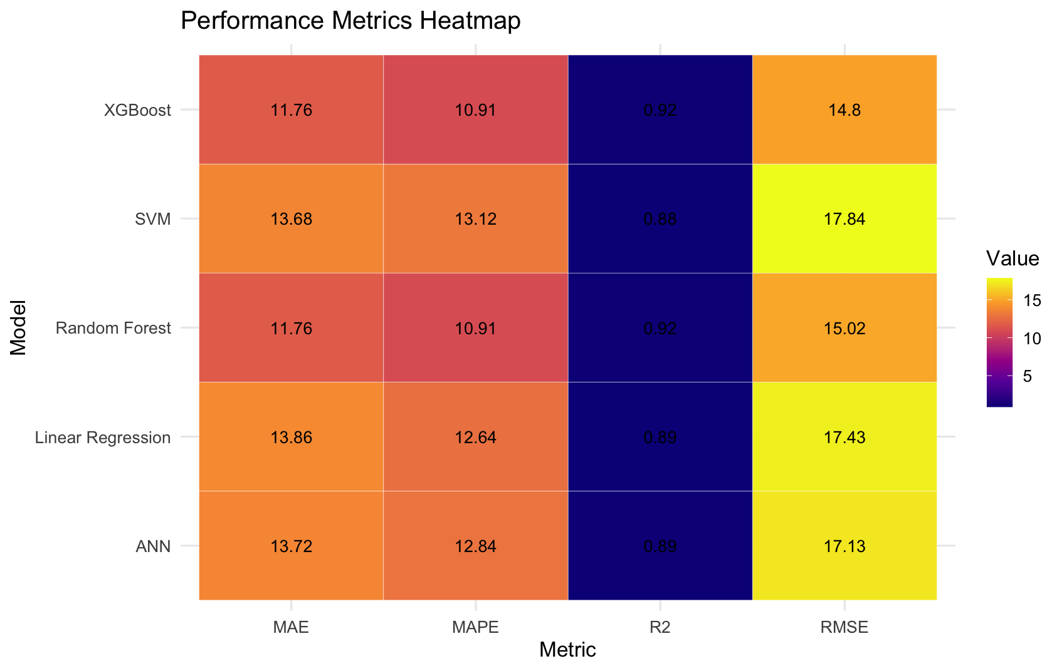
Figure 16

RESULTS
The results of the modeling phase indicate that the Artificial Neural Network (ANN) achieved the best overall predictive performance, slightly outperforming the multiple linear regression baseline in all evaluation metrics. ANN reached an RMSE of 17.13, MAE of 13.72, R² of 0.893, and MAPE of 12.84%, demonstrating its ability to capture complex and nonlinear relationships within the dataset. The linear regression model also performed well with an R² of 0.889, confirming the strong explanatory power of the engineered features. Models such as Random Forest and XGBoost showed comparable results and validated the robustness of ensemble methods in this context. Although Support Vector Machine (SVM) had slightly lower accuracy, its results were still within an acceptable range. Feature engineering steps, including the calculation of Haversine distance, transformation of order time into time-of-day categories, and the introduction of a delivery category through k-means clustering, contributed significantly to the improvements in model performance. These transformations helped capture meaningful patterns, particularly the effects of traffic, delivery distance, and order timing on delivery duration.

CONCLUSION
n conclusion, this study successfully explored and modeled the key factors influencing Amazon’s last-mile delivery performance using a comprehensive dataset. Through extensive exploratory analysis and statistical testing, it was shown that delivery time is significantly affected by traffic conditions, weather, geographic delivery area, and delivery agent characteristics such as age and rating. By applying appropriate imputation techniques and designing informative features, the predictive models were able to explain delivery time with high accuracy. Among the models applied, the Artificial Neural Network yielded the most reliable results, confirming the value of deep learning approaches in logistics prediction problems. These findings not only enhance the understanding of delivery performance drivers but also provide practical insights for improving customer satisfaction and operational efficiency in e-commerce logistics.

REFERENCES

• Chen, T., & Guestrin, C. (2016). XGBoost: A scalable tree boosting system. Proceedings of the 22nd ACM SIGKDD, 785–794.

• Wang, L., Zhang, Y., & Li, J. (2021). Predicting Last-Mile Delivery Time Using Machine Learning Algorithms. Journal of Logistics, 34(2), 112–126.

